Programming the onboard configuration memory

in Intel Quartus

This tutorial is made with Quartus 18.1 for windows but different versions will also work. Its written for the FPGA Board V2.1 By D. Keekstra.

# Preparing the program file

To program your FPGA configuration to the on the onboard memory we need to convert our SRAM object file (.sof) to an indirect configuration file (.jic).

1. Open your Quartus project in Quartus. Be sure the assembler step in Quartus has completed:

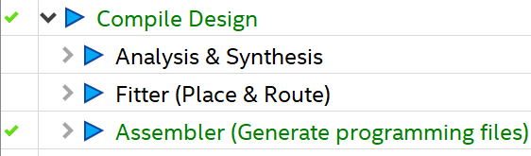

1. Open the conversion window by clicking File->Convert Program Files

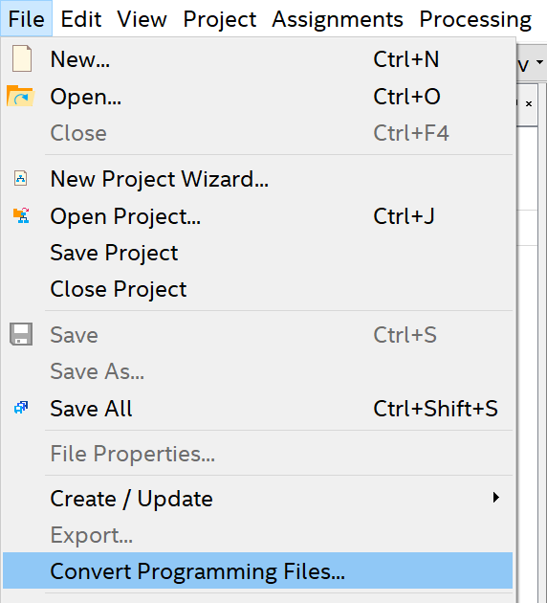

1. Now the conversion window will popup. Change the values according to the letters in the list

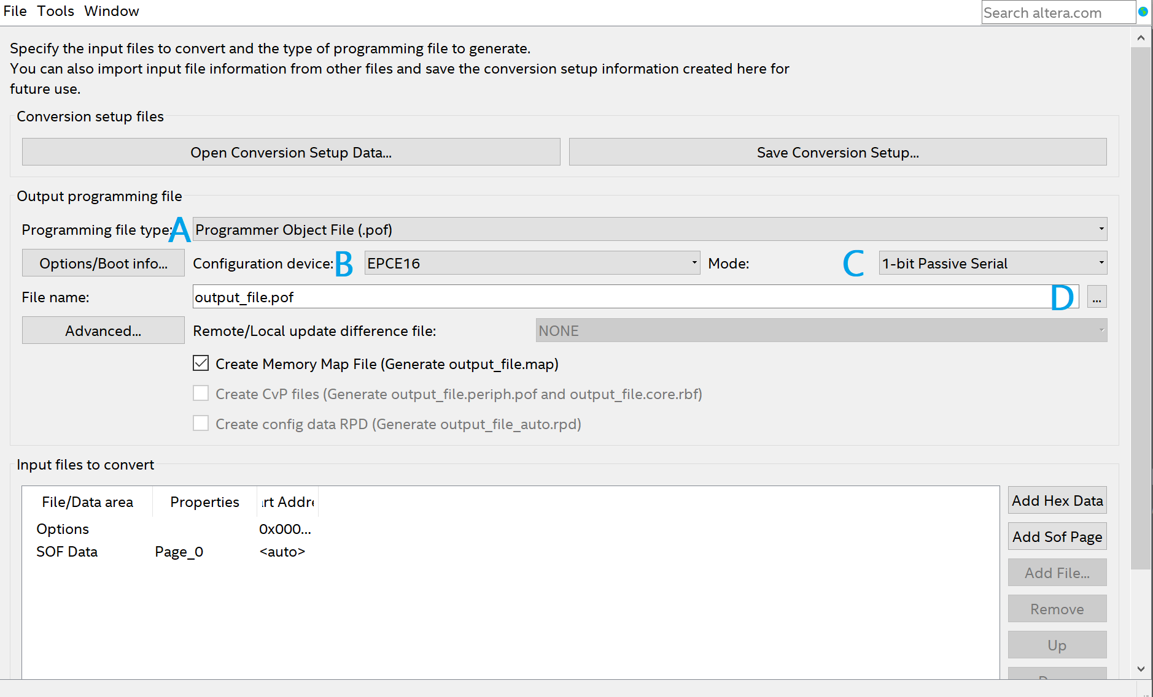

1. Choose JTAG Indirect Configuration File (.jic)
2. Choose EPCS4
3. Choose Active Serial
4. Select the output directory of your project. (by default in the output_files folder of your project folder)
5. Click on the Flash Loader. Than press the button Add Device..

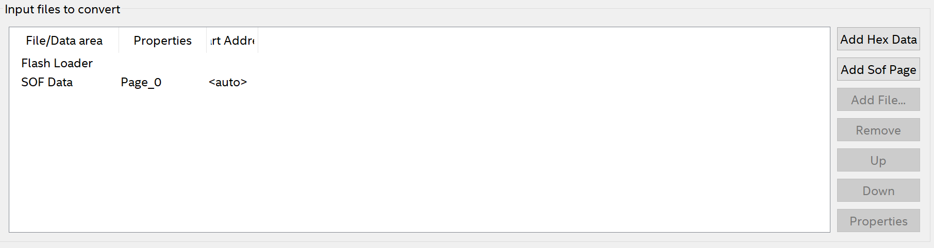

1. Select from the Cyclone 10 LP family the 10CL016Y and click ok.

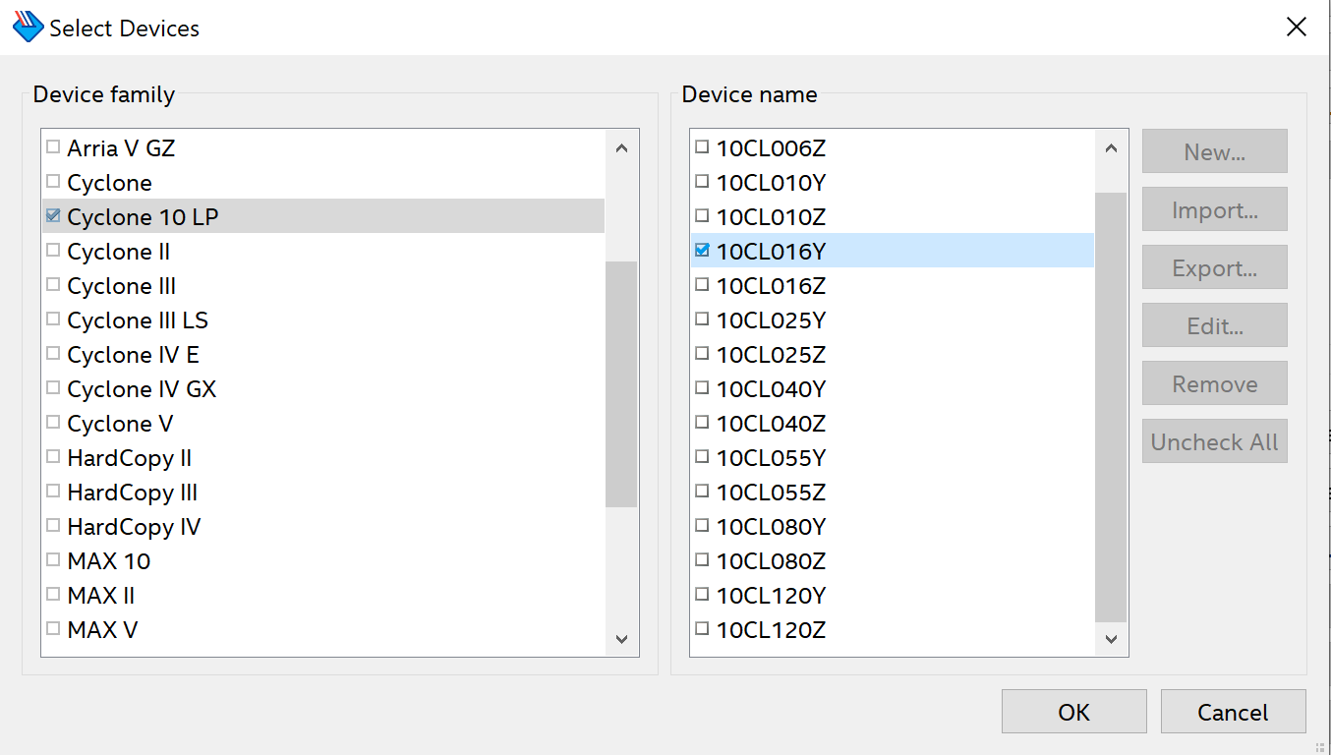

1. Click on SOF Data. Now click on add File.. Here you can select the .sof file from your project. (default in the output_files folder of your project)
2. The result should look like the picture below. When it does click Generate to create the .jic file.

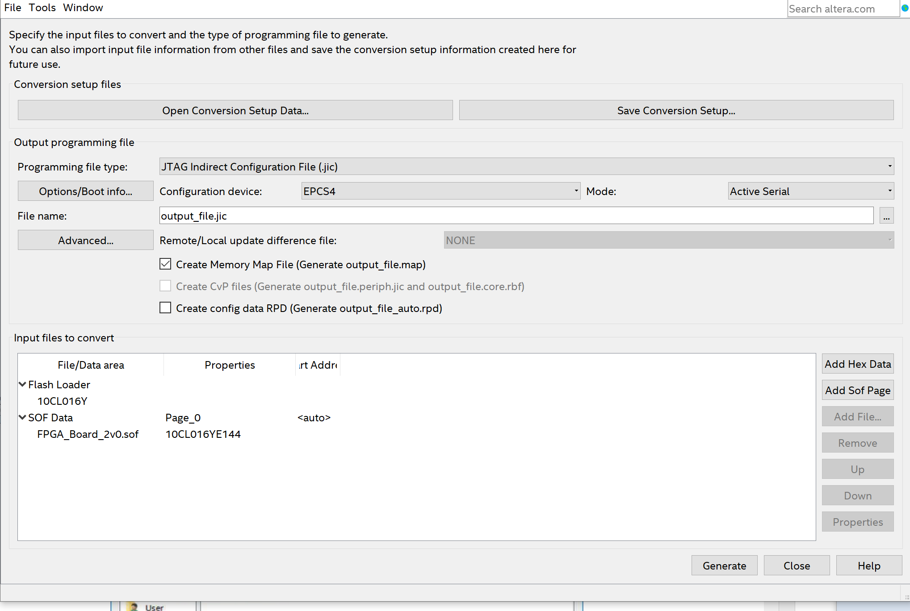

1. When you get the success message you can close the message and the window.

# Program your device

1. Open the programmer tool in the menu under Tools->Programmer
2. The next window will open:

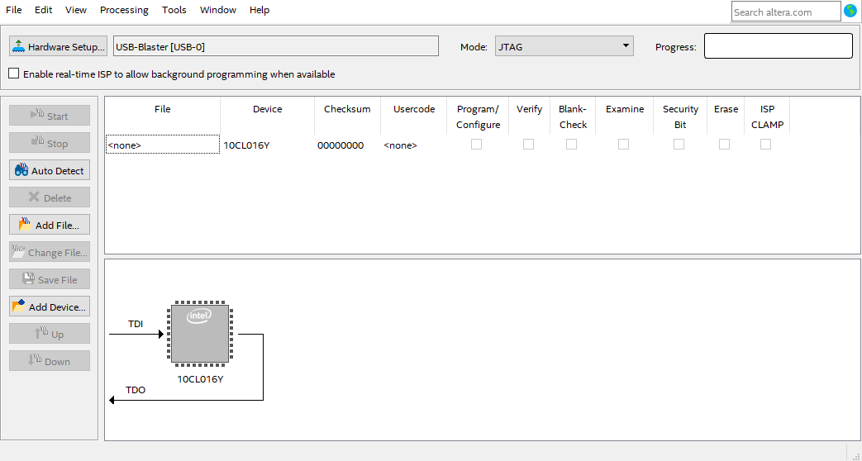

1. When there is no USB-Blaster next to the Hardware Setup button, Click on hardware setup and dubble click the USB-Blaster and click close

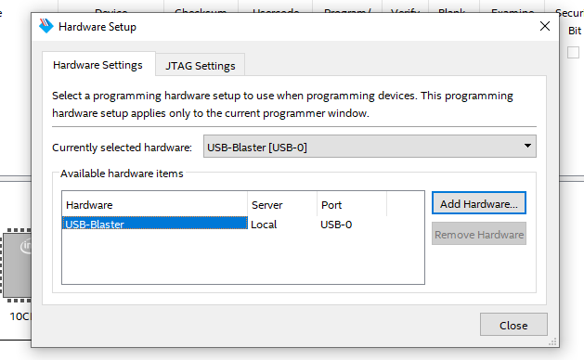

1. Now click the Auto detect. The USB-Blaster will detect the FPGA and you will see a screen as in in the picture of step 2.
2. Now Double click on the <none> row and select the generated jic file from part 1

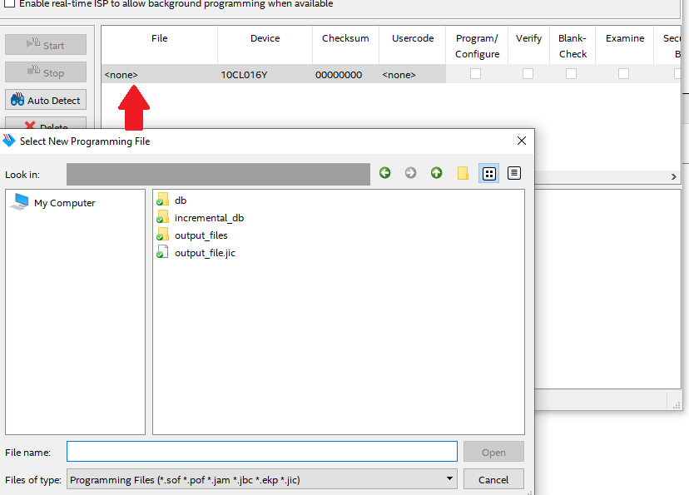

1. This will change the view and show a memory next to the FPGA:

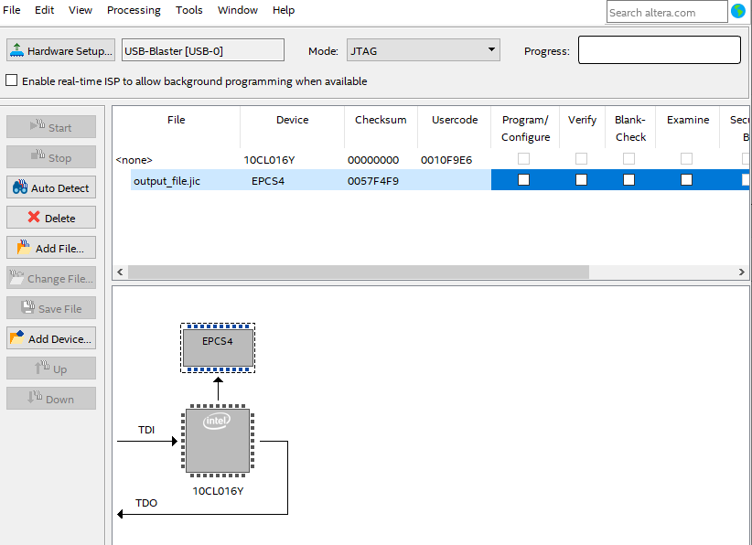

1. By selecting Program/Configure you can now press start to program your configuration memory.
2. For erasing deselect the Program/Configure checkbox and select the erase checkbox and press start.